As a next step for better visualization, we added donor data by manually filling the gap of missing data for a month and conducted a placebo test for pre-treatment to show that the target treatment effect does not happen in the pre-treatment period.

For the additional donor data, we processed PM2.5 data from Baghdad, Iraq. This data was lacking with 2020–08 PM2.5. We manually fill this missing data by getting the average between 2020-07 and 2020-09, then append it to the merged panel dataset and rerun the synthetic counterfactual generation in R.

After adding Baghdad data, we got much better synthetic counterfactual that fits more accurately in pre-treatment.
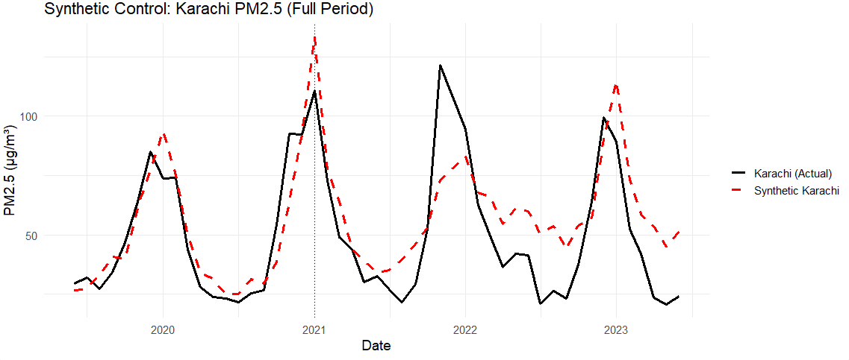

(Fig 8. A plot with an actual Karachi (black) and revised synthetic Karachi (red). The pre-treatment trend for revised synthetic Karachi is now a lot more similar than before, shown in Fig 6.)

We also applied robust STL on the revised version to remove extreme outliers and get smoother estimates.
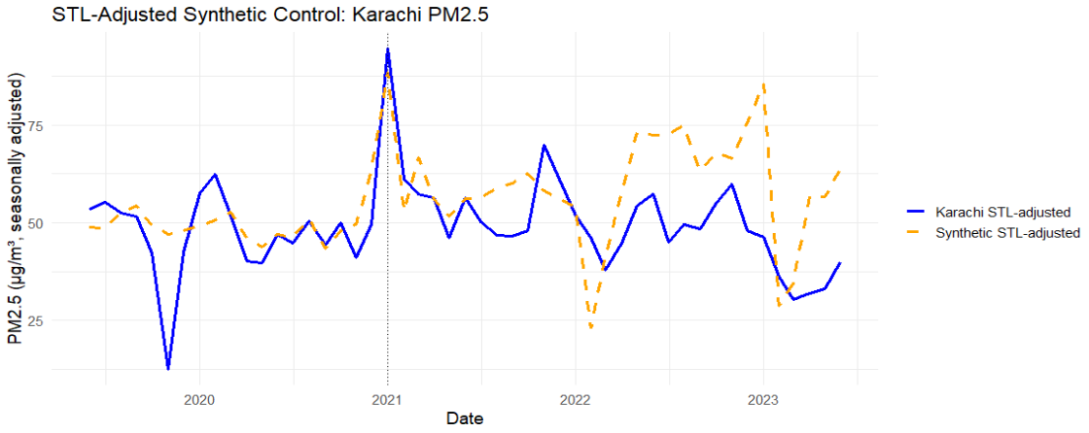
(Fig 9. A plot with robust-STL-adjusted actual Karachi and synthetic Karachi. Now the plot shows a clearer difference between the two in post-treatment periods.)

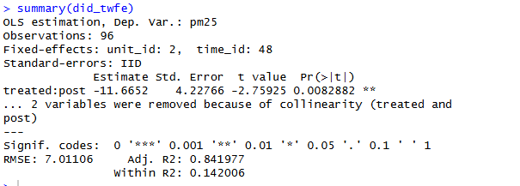
(Fig 10. A statistical result of DiD test between actual and synthetic in post treatment with OLS with Two-Way Fixed Effects model estimation. The estimated treatment effect (Euro-V on Karachi PM2.5) is –11.67 μg/m³, meaning that after treatment, actual Karachi PM2.5 is 11.7 units lower relative to its synthetic control. This effect is statistically significant at the 1% level with p-value = 0.008)

Placebo test is performed with fake treatment in 2020-01 within pre-treatment period.
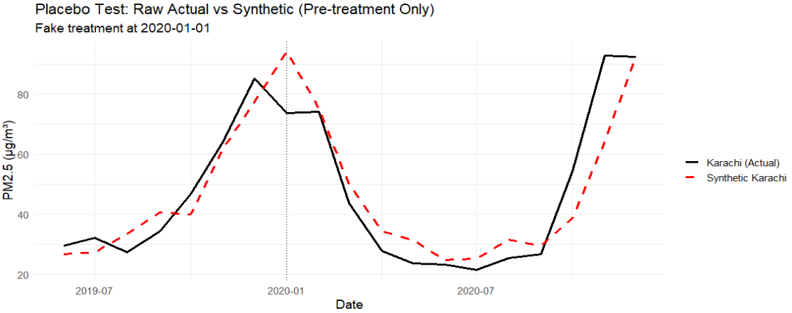
(Fig 11. A plot of actual Karachi and synthetic Karachi with fake treatment in 2020-01. There is no or little difference between the two in the fake-post-treatment period.)

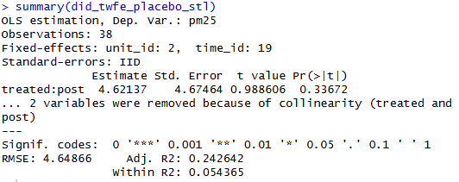
(Fig 12. A statistical result of placebo DiD test between actual and synthetic with fake-treatment. The placebo “effect” is +4.62 μg/m³, but it is not statistically significant (p-value = 0.337 > 0.05). This indicates no meaningful divergence between actual and synthetic Karachi at the fake treatment date. The placebo test supports the parallel trends assumption, because the synthetic and actual series do not show a significant break before the real policy.)

